Q1. Search and display all \*.c and \*.h files in all subdirectories starting from current directory.

Answer:- find -type f -name “\*.[c\|h]”

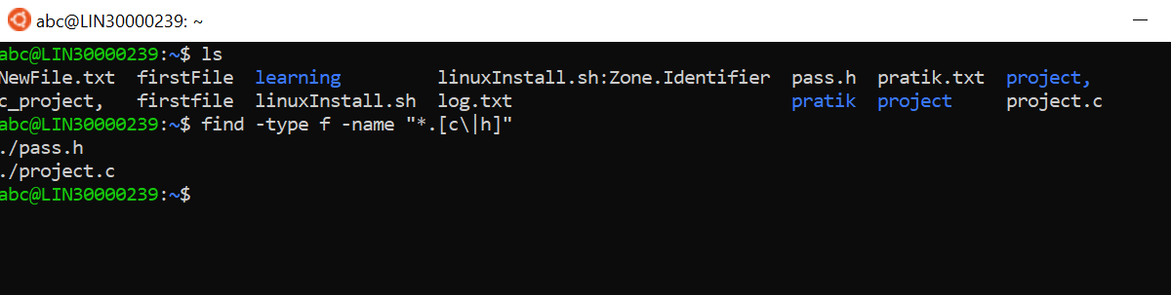

Q2. Search and display all directories in all subdirectories starting from current directory

Q3. Search and display all files with permissions only rw with user and execute permission for others

